Project Proposal: Automated Metadata Extraction and Multi-Label Classification for TTRPG Systems

1. Problem Statement & Business Value

Domain Context:
Modern Tabletop Role-Playing Games (TTRPGs) played on Virtual Tabletop (VTT) platforms, such as Foundry VTT, have evolved into highly complex simulation environments. These platforms rely on strict system architectures where every action, spell, or item is governed by underlying metadata (often called "tags" or "traits"). The VTT engine does not "read" the descriptive text of a spell to determine its effects; instead, it relies entirely on these assigned tags to trigger automations, calculate damage resistances, and enforce game rules.
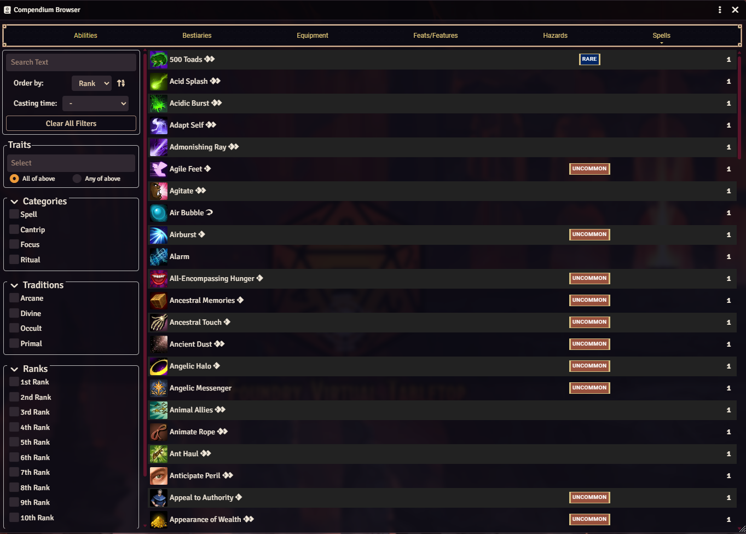

The Problem:
Game Masters (GMs) and homebrew content creators frequently design custom abilities, spells, and items to enrich their campaigns. While writing the narrative and mechanical description is a creative process, manually classifying and assigning the correct structural tags is a tedious, data-entry task. Human error during this manual tagging process is incredibly common and directly breaks the automation of the VTT.

Real-Life Example:
Imagine a Game Master creates a custom spell called "Lava Geyser". They write the following description for the players:
"You channel magical energy to rupture the earth, summoning a burst of molten rock. The eruption deals massive heat damage to anyone in the area and requires you to perform complex hand gestures to sustain it."
For this spell to function correctly in the VTT engine, the GM cannot just save the text. They must navigate complex menus and manually assign a specific array of tags, such as: [Evocation, Fire, Primal, Manipulate, Concentrate, Area of Effect].
- If the GM forgets the "Fire" tag, a Fire Elemental monster (which should be immune) will incorrectly take full damage in the software.
- If they forget the "Manipulate" tag, casting the spell won't trigger an enemy's automated reaction (like an Attack of Opportunity).
- If they forget "Evocation", characters with specific magical wards won't automatically resist the spell.

A single missing tag completely compromises the mechanical integrity of the game session, forcing the GM to stop the game, debug the system, and fix the metadata manually.

Business Value & Solution:
This project delivers a predictive NLP model that acts as an intelligent assistant for content creators. By inputting the raw, unstructured text description of a new ability, the model will automatically predict and generate the required array of system tags. This solution drastically reduces data-entry time, eliminates human error, and ensures absolute mechanical compatibility with the platform's automation framework out of the box.
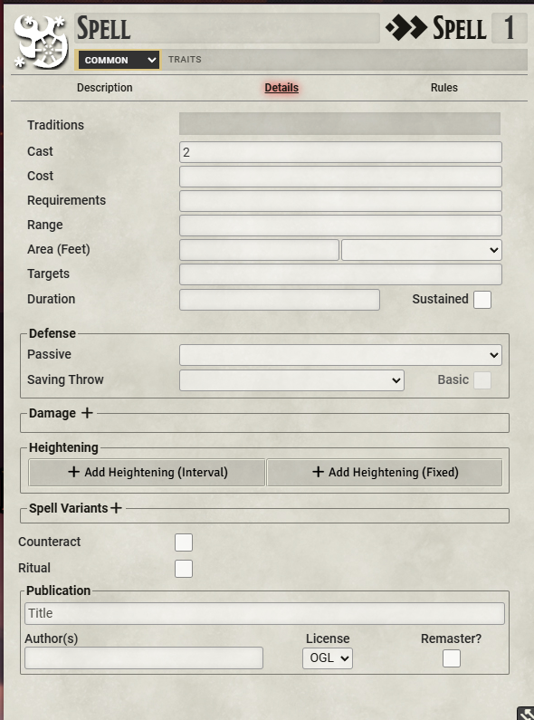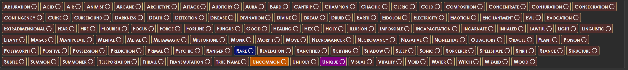

2. Data Understanding & Preparation
The project utilizes unstructured text data and metadata sourced directly from the official system reference document for Pathfinder 2e.
- Data Source: The primary dataset will be extracted from Archives of Nethys (https://2e.aonprd.com/Spells.aspx), the official compendium of all published spells.
- Data Engineering (Web Scraping): A custom Python script will be developed to scrape this database. It will extract the descriptive text (the narrative and mechanical effects of the spell) as the input feature (X) and map it to the corresponding array of metadata tags (Traits, Magical Traditions, and Schools) as the target variables (y).
- Data Cleaning: Text preprocessing will involve stripping HTML markup, normalizing text (lowercasing, removing special characters), removing standard English stop words, and tokenizing the data to prepare it for neural network embeddings.
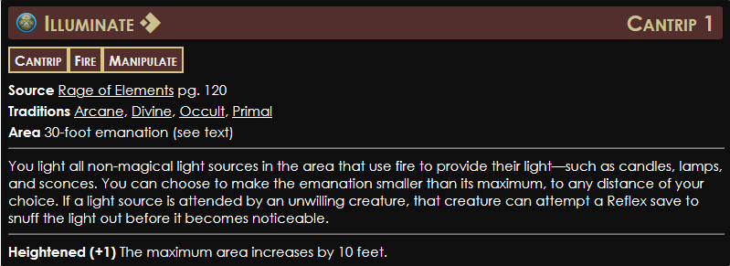

Feature Definition (Input Variables & Target Variables)
To train the machine learning model effectively, the dataset will be structured into specific inputs ($X$) and outputs ($y$):
Input Feature 1 (Unstructured Text / $X_{1}$): The descriptive text of the spell, detailing both the narrative and mechanical effects. The model will analyze this raw text to identify semantic patterns and specific keywords (e.g., terms like "burn," "radius," or "mind").
Input Feature 2 (Structured Data / $X_{2}$): The Spell Rank (e.g., Cantrip, Rank 1-10). This feature will be provided by the user as an additional numerical input, as the rank of a spell often correlates with specific systemic traits (e.g., high-rank spells are statistically more likely to possess the "Incapacitation" tag).
Target Variables ($y$): The corresponding array of metadata tags, including Traits, Magical Traditions, and Schools. These serve as the correct labels the model must learn to predict based on the input features.

Data Preparation & Cleaning
Raw data extracted from compendiums requires significant preprocessing before it can be interpreted by a neural network:
Text Normalization: Text preprocessing will involve stripping HTML markup, normalizing text (lowercasing, removing special characters), and removing standard English stop words.
Tokenization & Keyword Extraction: The cleaned data will be tokenized to prepare it for neural network embeddings. This step converts textual keywords into numeric vectors, allowing the algorithm to assign mathematical weights to domain-specific terminology.

3. Modeling Approach: Multi-Label Text Classification
Because a single spell can possess multiple tags simultaneously (e.g., Evocation, Fire, Concentrate), this is inherently a multi-label classification problem.
- Architecture: The core model will be a deep learning Neural Network built with PyTorch. It will utilize an Embedding Layer to convert tokenized text into dense vector representations, allowing the model to capture the semantic meaning of the descriptions.
- Contextual Processing: The embeddings will be processed through hidden layers (Linear or LSTM) to identify patterns linking specific wording to specific tags.
- Output & Loss Function: The final layer will output probabilities for every possible tag using a Sigmoid activation. The network will be optimized using BCEWithLogitsLoss (Binary Cross Entropy), which is specifically designed for multi-label scenarios where classes are independent of one another.

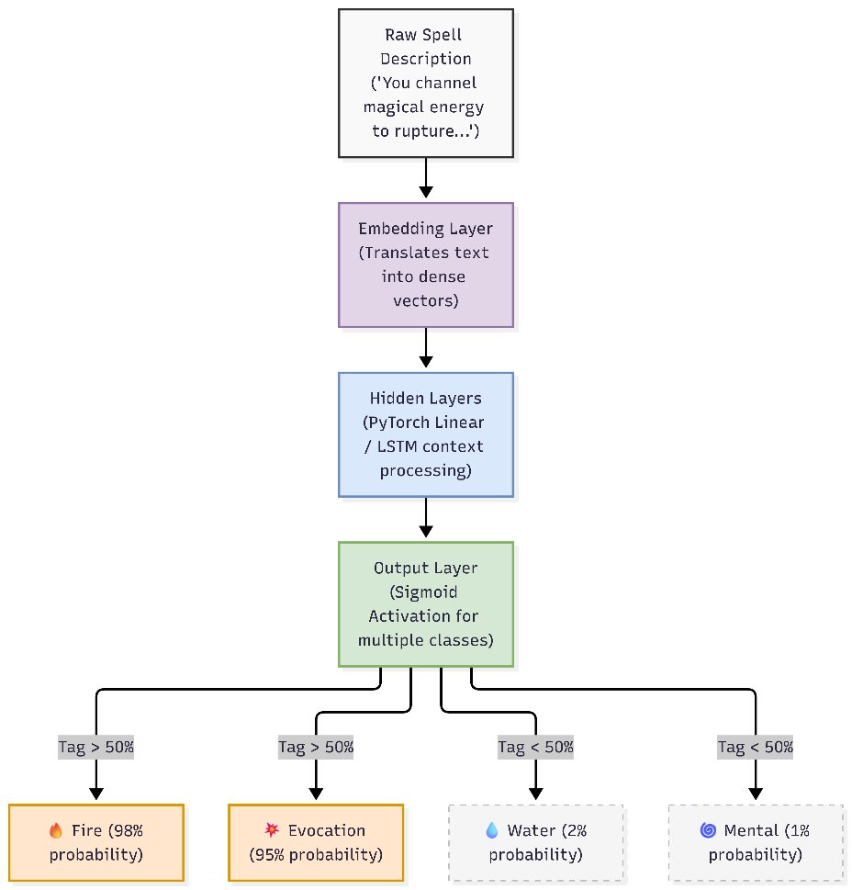

4. Technology Stack
To execute this practice challenge within the required timeframe, the following technologies will be utilized:

- Data Collection (Scraping): requests, BeautifulSoup (for extracting data from the Archives of Nethys).
- Data Manipulation & EDA: pandas, matplotlib, seaborn (for handling datasets and visualizing class imbalances).
- Machine Learning Framework: PyTorch (for building, training, and evaluating the neural network).
- Text Processing (NLP): NLTK or spaCy (for tokenization and stop-word removal).
- Deployment / UI: Streamlit (to build a functional front-end interface where the stakeholder can test the model).

5. Project Methodology (AMD Framework)
This project will follow an iterative process, structured into defined sprints:
- Iteration 1 (Data & Baseline): Building the web scraper for AON, conducting Exploratory Data Analysis (EDA) on spell traits, and preparing the DataLoader.
- Iteration 2 (Modeling): Designing the PyTorch architecture, writing the training loop, and debugging tensor dimensions.
- Iteration 3 (Evaluation & Value Creation): Tuning hyperparameters, evaluating F1-Scores, and deploying the trained model via a Streamlit web application.

6. Evaluation & Success Criteria
Since the dataset will likely exhibit severe class imbalance (e.g., common tags like 'Manipulate' appearing much more frequently than rare ones like 'Water'), traditional Accuracy is not a reliable metric.
- Primary Metric: The model will be evaluated using the Macro and Micro F1-Score, ensuring that both frequent and rare tags are predicted reliably.
- Deliverable: A working prototype (Streamlit app) capable of taking a custom text input and generating a properly formatted tag array.

